Data Analysis
Course Project Report on
DATA ANALYSIS IN OPENOFFICE
SUBMITTED IN PARTIAL FULFILLMENT OF THE REQUIREMENTS FOR THE DEGREE OF
BACHELOR OF TECHNOLOGY IN
AIML-A

OF
VISHWAKARMA INSTITUTE OF TECHNOLOGY

Savitribai Phule Pune University

12414243
UNDER THE GUIDANCE OF
MRS.SUPRIYA TELSANG


DEPARTMENT OF ENGINEERING SCIENCE AND HUMANITIES

BANSILAL RAMNATH AGARWAL CHARITABLE TRUST’S
VISHWAKARMA INSTITUTE OF TECHNOLOGY
(An Autonomous Institute affiliated to Savitribai Phule Pune University)

2024 - 2025

BANSILAL RAMNATH AGARWAL CHARITABLE TRUST’S

VISHWAKARMA INSTITUTE OF TECHNOLOGY
(An Autonomous Institute affiliated to Savitribai Phule Pune University)

PUNE – 411037


CERTIFICATE

This is to certify that the Course Project titled DATA ANALYSIS IN OPENOFFICE submitted by 12414243 is in partial fulfillment for the award of Degree of Bachelor of Technology in DEPARTMENT OF ENGINEERING, SCIENCES AND HUMANITIES of Vishwakarma Institute of Technology, Savitribai Phule Pune University. This project report is a record of Bonafide work carried out by him under my guidance during the academic year 2023-24.

Guide HOD, DESH
Prof. SURPIYA TELSANG Prof. Dr. C. M. Mahajan

Place: VIT, Pune
Date:

Bansilal Ramnath Agarwal Charitable Trust’s

Vishwakarma Institute of Technology, Pune-37
Department of Engineering Science and Humanities

PROJECT DETAILS

Group No : 2
Members:
Roll No. | PRN | Name of Student | Contact No. | Email ID
7 | 12414240 | Abhinandan Bardia | 9302221467 | abhinandan.bardia24@vit,edu
8 | 12414243 | Abhishek Patil | 9011019161 | abhishek.patil1241@vit.edu
9 | 12412164 | Abhishek Singh | 7340194242 | singh.abhishek24@vit.edu
10 | 12410087 | Pradyumna Adhari | 8208985335 | pradyumna.adhari24@vit.edu
11 | 12412960 | Adit Pakhode | 9819869743 | adit.pakhode24@vit.edu
12 | 12411764 | Aditi Patil | 9067310282 | aditi.patil241@vit.edu

Academic Year : 2024-2025
Project Title : Data Analysis in OpenOffice
Project Area : OpenOffice
Internal Guide : Mrs. Supriya Telsang

Signature of Internal Guide

ACKNOWLEDGEMENT

I am immensely grateful for the support and guidance provided by numerous individuals throughout the course of this project.

First and foremost, I would like to express my deepest gratitude to Prof. Supriya Telsang for her invaluable guidance and mentorship. Her extensive knowledge and unwavering support have been pivotal to the successful completion of this project. Prof. Telsang's encouragement, insightful feedback, and patience have motivated me to strive for excellence. Her commitment to academic excellence and dedication to her students have been a source of great inspiration.

I also wish to extend my heartfelt appreciation to my colleagues and friends who have provided me with continuous support and motivation. Their constructive feedback and encouragement have been crucial in refining my work. Special thanks to [Name of Colleague/Friend], whose insightful suggestions and critical analysis have greatly contributed to the quality of this project. Their willingness to engage in discussions and provide honest feedback has been invaluable.

I am deeply thankful to my family for their unwavering support and understanding throughout this journey. Their belief in my abilities has been a constant source of strength. My parents, [Parent's Names], have always encouraged me to pursue my academic goals and have been my pillars of support. Their love, patience, and encouragement have been instrumental in helping me overcome challenges and stay focused on my objectives.

Furthermore, I acknowledge the resources and assistance provided by OpenOffice, which have been instrumental in conducting and presenting this data analysis. The user-friendly interface and powerful tools of OpenOffice have greatly facilitated the completion of this project. The ability to efficiently organize, analyze, and visualize data using OpenOffice has been a significant advantage.

I would also like to thank [Name of Institution/Organization] for providing me with the necessary resources and environment to conduct my research. The access to relevant literature, software, and other resources has been crucial in the successful execution of this project. The support and cooperation of the administrative and technical staff have also been greatly appreciated.

Additionally, I am grateful to the participants and contributors who provided data and insights for this project. Their willingness to share their experiences and knowledge has enriched the quality of this analysis. Without their cooperation, this project would not have been possible.

Lastly, I would like to express my gratitude to all those who, directly or indirectly, have contributed to the successful completion of this project. Your support, encouragement, and guidance have been invaluable, and I am deeply grateful for your contributions.

Thank you all for your unwavering support and encouragement.

- Introduction

In our Data Analysis lab classes, our group demonstrated the same analytical techniques typically performed using Excel, but we utilized OpenOffice instead. Each team member was responsible for explaining different features of Excel, showcasing their application in OpenOffice. Abhishek Patil provided an insightful explanation of the Normal distribution, highlighting its significance in statistical analysis and data interpretation. Normal distribution is a fundamental concept in statistics, often used to represent real-valued random variables whose distributions are not known. Aditi Patil delved into conditional formatting, demonstrating how it can be used to visually differentiate data based on specific criteria, making data analysis more intuitive and efficient. Conditional formatting is a powerful tool that helps in identifying trends and patterns in data, thereby enhancing the decision-making process. Adit Pakhode tackled regression and curve fitting, illustrating how these techniques can be employed to model relationships between variables and predict future trends. Regression analysis is crucial for understanding the relationships between variables and for making predictions. Abhishek Singh explained the functionalities of VLOOKUP and HLOOKUP, emphasizing their utility in searching and retrieving data from large datasets. These functions are essential for data management and analysis, allowing users to quickly find and reference data across different sheets. Abhinandan Bardia focused on pivot tables and pivot charts, showcasing their power in summarizing, analyzing, and presenting data in a dynamic and interactive manner. Pivot tables and charts are indispensable tools for data analysis, enabling users to organize and summarize complex data sets efficiently. Lastly, Pradyumna Adhari explained the various types of charts available, demonstrating how they can be used to effectively visualize data and communicate insights. Charts are vital for data visualization, helping to convey information clearly and concisely. Each member's contribution was crucial in providing a comprehensive understanding of these features, and together, we were able to effectively demonstrate the versatility and power of OpenOffice in performing complex data analysis tasks.

- Literature Survey on Data Analysis Techniques in OpenOffice and Excel

In the realm of data analysis, tools like OpenOffice and Excel have become indispensable due to their robust functionalities and user-friendly interfaces. This survey explores various data analysis techniques including normal distribution, regression and curve fitting, conditional formatting, HLOOKUP and VLOOKUP, pivot tables, and different types of charts, comparing their implementation in both OpenOffice and Excel.
Normal Distribution
Normal distribution is a fundamental concept in statistics, often used to represent real-valued random variables whose distributions are not known. In OpenOffice, the NORMDIST function is used to calculate the normal distribution, similar to Excel's NORM.DIST function. Both tools provide comprehensive support for statistical analysis, making them suitable for academic and professional use.
Regression and Curve Fitting
Regression analysis is crucial for understanding the relationships between variables and for making predictions. OpenOffice offers the LINEST function for linear regression, which is comparable to Excel's LINEST function. Curve fitting, which involves finding the best-fit curve for a set of data points, can be performed using the TREND function in both OpenOffice and Excel. These functions are essential for data scientists and analysts who need to model and predict trends.
Conditional Formatting
Conditional formatting is a powerful tool that helps in identifying trends and patterns in data, thereby enhancing the decision-making process. In OpenOffice, conditional formatting can be applied through the Format menu, allowing users to set rules based on cell values. Excel offers a similar feature through the Home tab, providing a wide range of formatting options. Both tools enable users to visually differentiate data based on specific criteria, making data analysis more intuitive and efficient.
HLOOKUP and VLOOKUP
HLOOKUP and VLOOKUP are essential functions for data management and analysis, allowing users to quickly find and reference data across different sheets. In OpenOffice, these functions are available as HLOOKUP and VLOOKUP, similar to Excel. They are particularly useful for large datasets where manual searching would be impractical.
Pivot Tables and Charts
Pivot tables and charts are indispensable tools for data analysis, enabling users to organize and summarize complex data sets efficiently. OpenOffice provides pivot table functionality through the Data menu, while Excel offers it through the Insert tab. Both tools allow users to create dynamic and interactive summaries of their data, making it easier to identify key insights.
Different Types of Charts
Charts are vital for data visualization, helping to convey information clearly and concisely. OpenOffice supports various types of charts including bar, line, pie, and scatter charts, accessible through the Insert menu. Excel offers a similar range of chart types through the Insert tab. Both tools provide extensive customization options, allowing users to tailor their charts to their specific needs.
Conclusion
In conclusion, both OpenOffice and Excel offer a wide range of functionalities for data analysis, each with its own strengths. OpenOffice is a free and open-source alternative to Excel, making it accessible to a broader audience. Excel, on the other hand, is widely used in professional settings due to its advanced features and integration with other Microsoft Office applications. Understanding the capabilities of both tools can help users choose the right one for their specific data analysis needs.

References
- OpenOffice Documentation: OpenOffice.org Documentation
- Microsoft Excel Documentation: Microsoft Support - Excel

- Methodology

1)Data collection method
The methodology for the presentation on data analysis techniques in OpenOffice and Excel involved several key steps to ensure comprehensive and accurate coverage of the topics. The data collection process was a crucial part of this methodology, with most of the data being sourced from Kaggle, a well-known platform for data science and machine learning datasets1. Additionally, some data was collected from research articles and documentation to provide a well-rounded perspective on the various techniques discussed.
2)Source of data collection (link)
- https://www.kaggle.com/code/aditimulye/adult-income-dataset-from-scratch/output
- https://www.kaggle.com/datasets/yasserh/student-marks-dataset/data
All the dataset have been filtered and cleaned to favor the operations to be performed on those data.

- Features provided by OpenOffice

OpenOffice is a versatile and powerful open-source office suite that offers a wide range of features for various types of document creation and data analysis. It includes several applications that cater to different needs, such as word processing, spreadsheets, presentations, graphics, databases, and more. Here are some of the key features provided by OpenOffice:
- Calc: OpenOffice Calc is a spreadsheet application that provides powerful tools for data analysis and visualization. It supports various functions and formulas, including statistical, financial, and mathematical functions. Calc also offers features like pivot tables, conditional formatting, and data validation, which help users analyze and interpret data effectively. Additionally, Calc supports multiple chart types, allowing users to create visually appealing data visualizations.
- Base: OpenOffice Base is a database application that enables users to create and manage databases. It supports various database formats, including MySQL, PostgreSQL, and Microsoft Access. Base offers tools for designing tables, queries, forms, and reports, making it suitable for both simple and complex database management tasks.
- Compatibility: OpenOffice is compatible with various file formats, including Microsoft Office formats (DOCX, XLSX, PPTX) and OpenDocument formats (ODT, ODS, ODP). This compatibility ensures that users can easily share and collaborate on documents with others, regardless of the software they use.
- Customization and Extensions: OpenOffice supports customization through extensions and add-ons. Users can enhance the functionality of OpenOffice by installing extensions that provide additional features and tools.

Screenshots of Dashboards

1.Abhishek Singh

HLOOKUP and VLOOKUP are essential functions for data management and analysis in spreadsheets.
- HLOOKUP (Horizontal Lookup) searches for a value in the top row of a table and returns a value in the same column from a specified row.
- VLOOKUP (Vertical Lookup) searches for a value in the first column of a table and returns a value in the same row from a specified column.
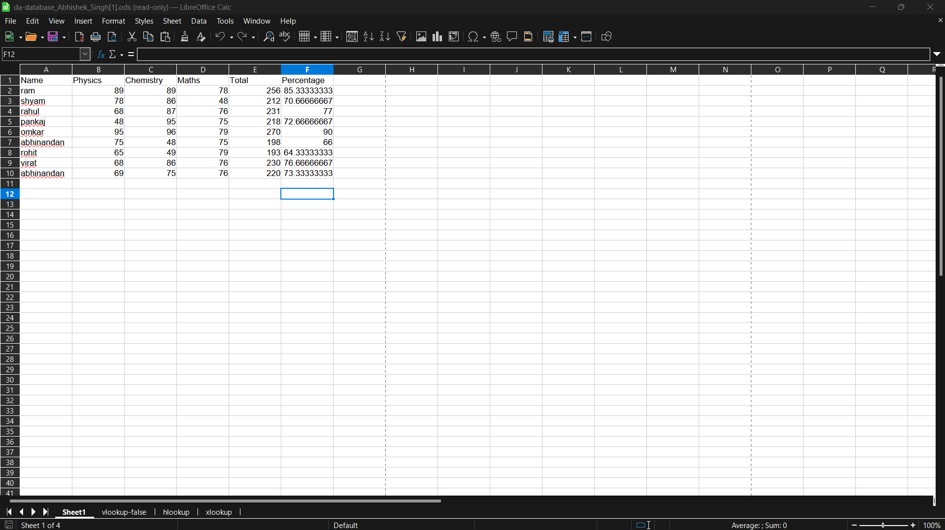
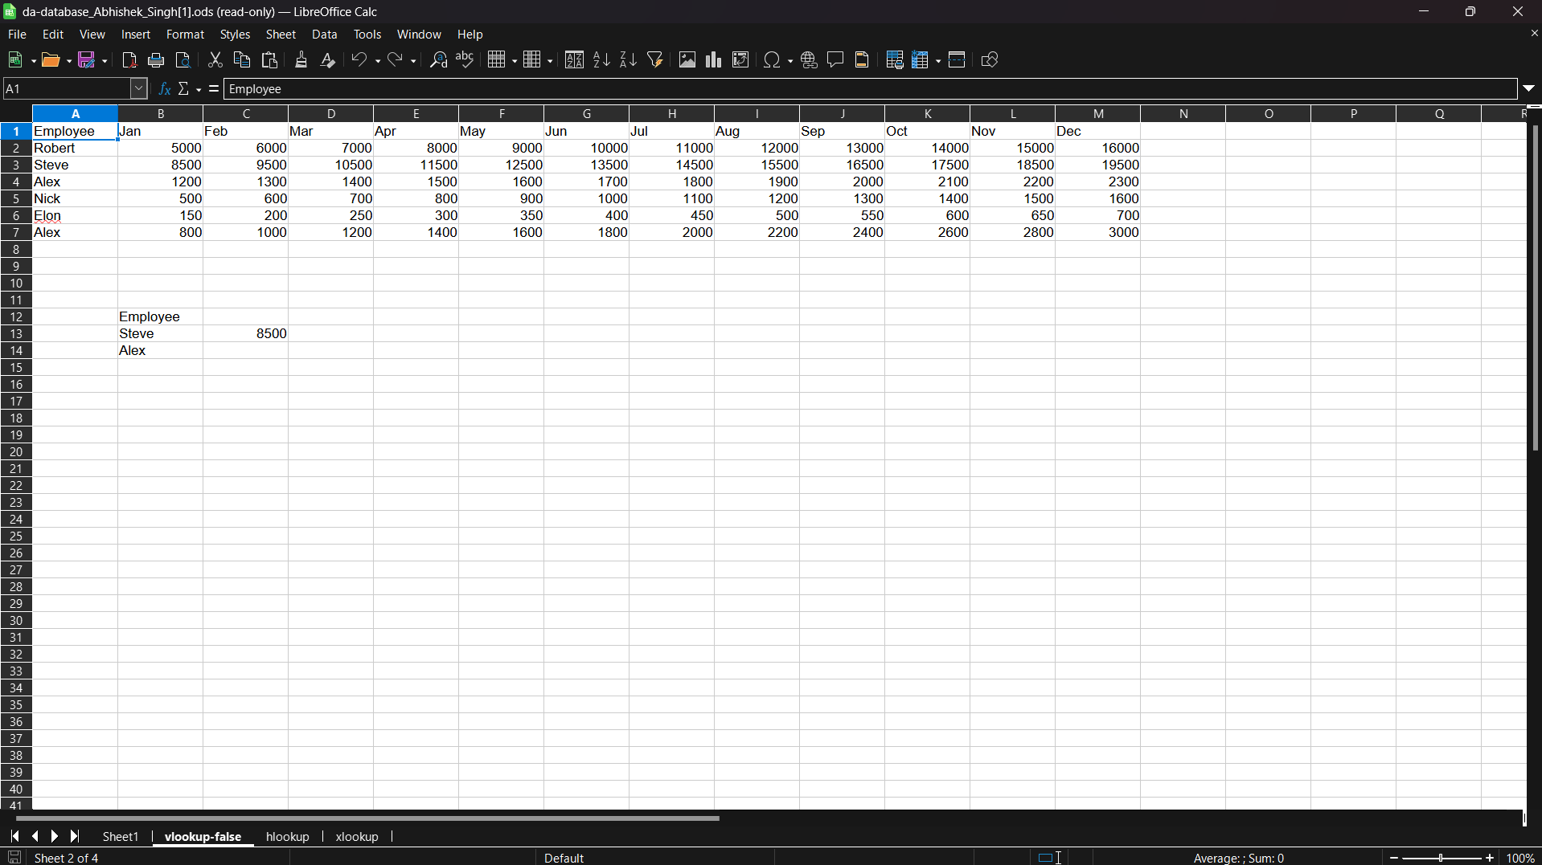
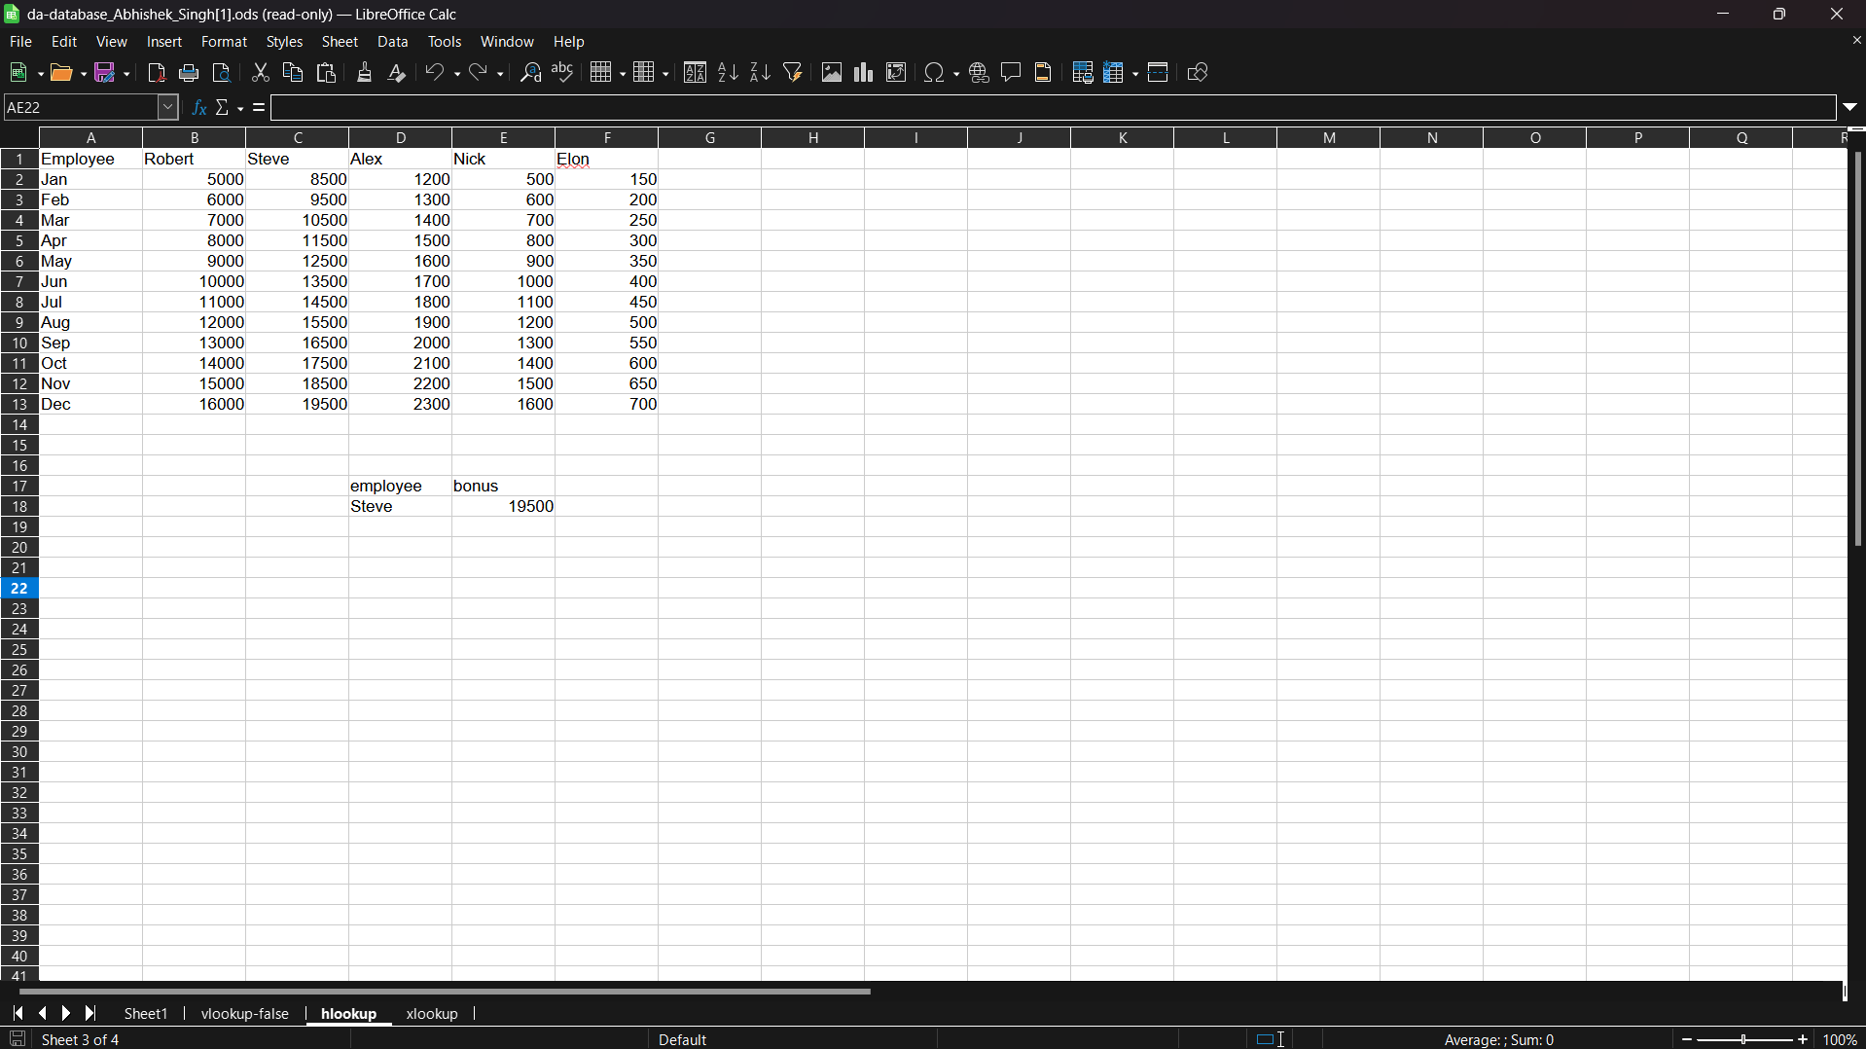
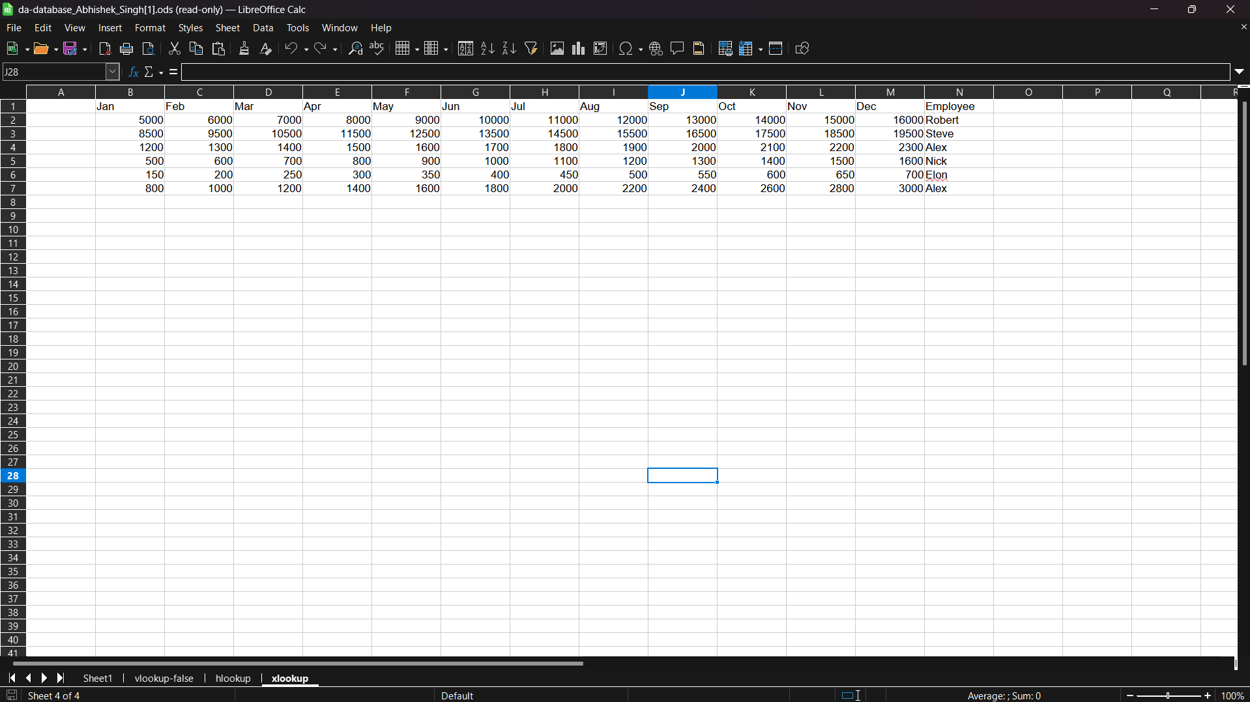

2.Adit Pakhode

This function helps in determining the linear relationship between variables, making it an essential tool for data scientists and analysts.
Curve Fitting involves finding the best-fit curve for a set of data points. This can be performed using the TREND function in both OpenOffice and Excel. Curve fitting is particularly useful when the relationship between variables is non-linear, allowing for more accurate modeling and prediction of trends.
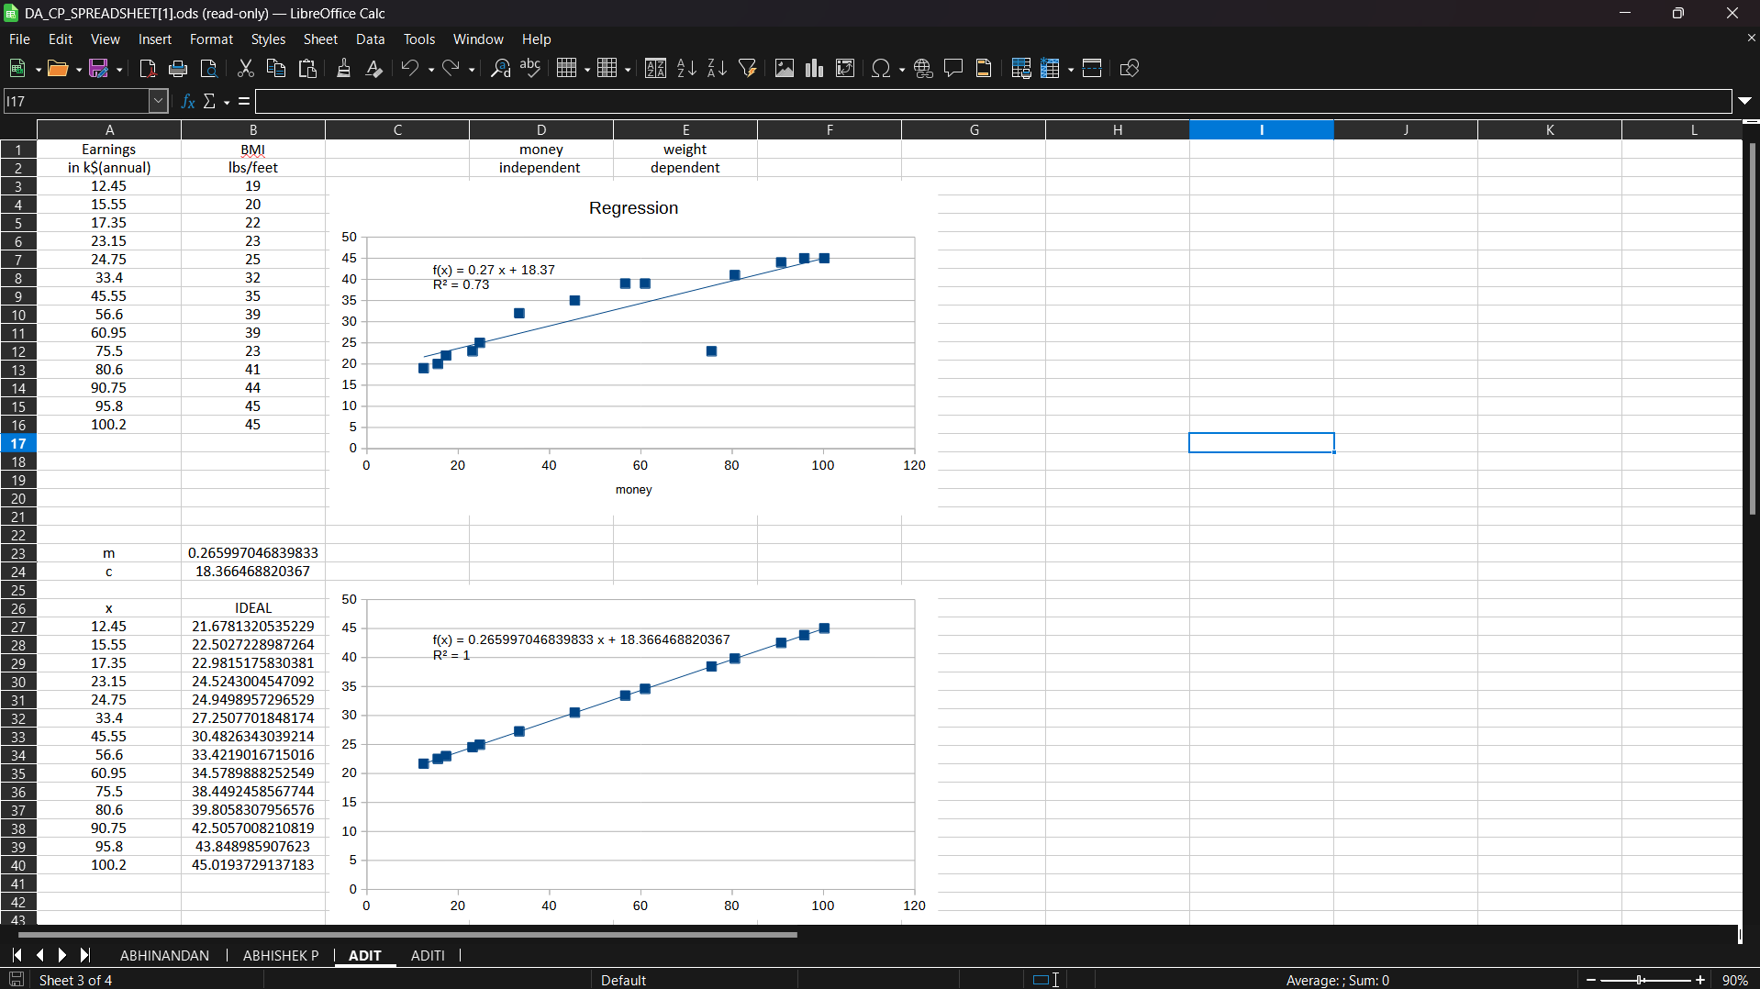

3.Abhishek Patil

Normal distribution is a fundamental concept in statistics, often used to represent real-valued random variables whose distributions are not known. In OpenOffice, the NORMDIST function is used to calculate the normal distribution, like Excel's NORM.DIST function. Both tools provide comprehensive support for statistical analysis, making them suitable for academic and professional use.
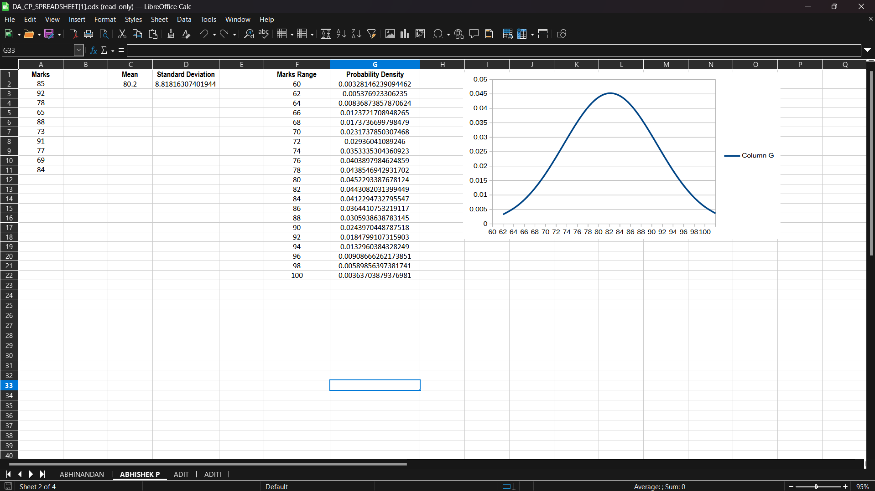

4.Aditi Patil

Conditional formatting is a powerful tool that helps in identifying trends and patterns in data, thereby enhancing the decision-making process. In OpenOffice, conditional formatting can be applied through the Format menu, allowing users to set rules based on cell values. Excel offers a similar feature through the Home tab, providing a wide range of formatting options. Both tools enable uses to visually differentiate data based on specific criteria, making data analysis more intuitive and efficient.
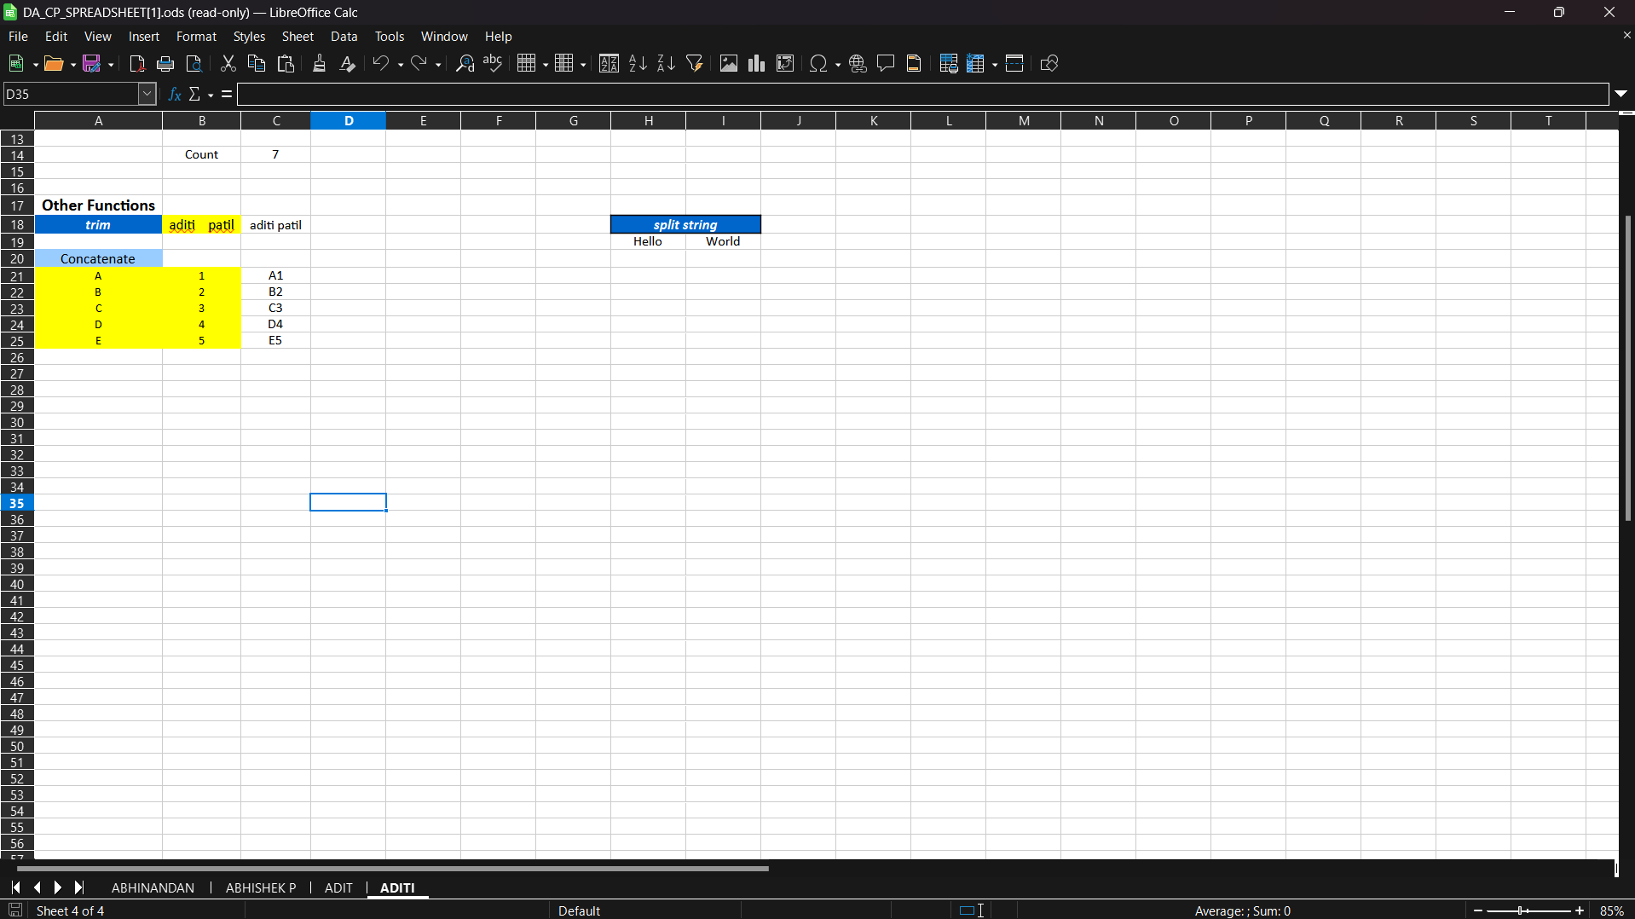

5.Abhinandan Bardia

Pivot tables and charts are indispensable tools for data analysis, enabling users to organize and summarize complex data sets efficiently. In OpenOffice, pivot table functionality is provided through the Data menu, while Excel offers it through the Insert tab. Both tools allow users to create dynamic and interactive summaries of their data, making it easier to identify key insights.
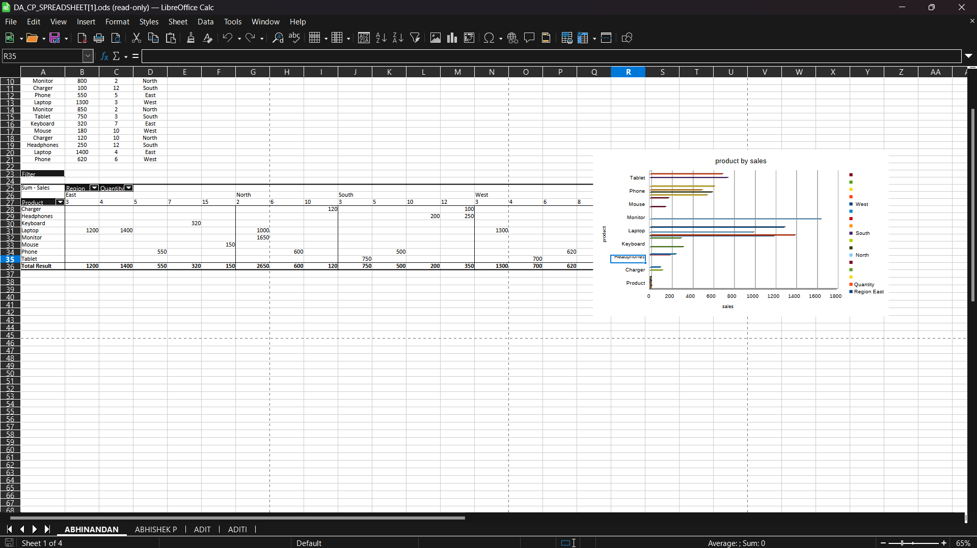

6.Pradyumna Adhari

Charts are vital for data visualization, helping to convey information clearly and concisely. OpenOffice supports various types of charts including bar, line, pie, and scatter charts, accessible through the Insert menu. Excel offers a similar range of chart types through the Insert tab. Both tools provide extensive customization options, allowing users to tailor their charts to their specific needs1
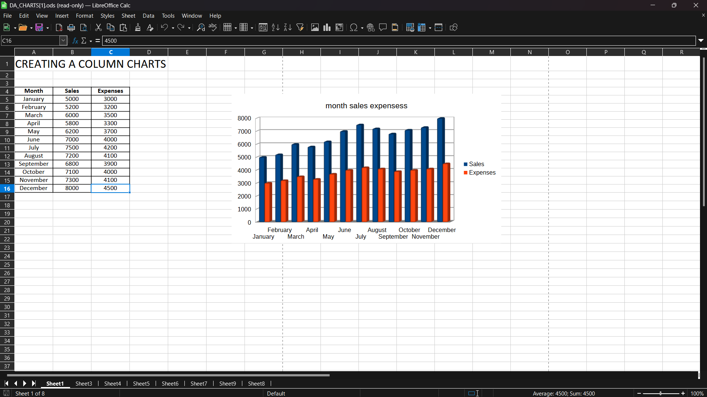
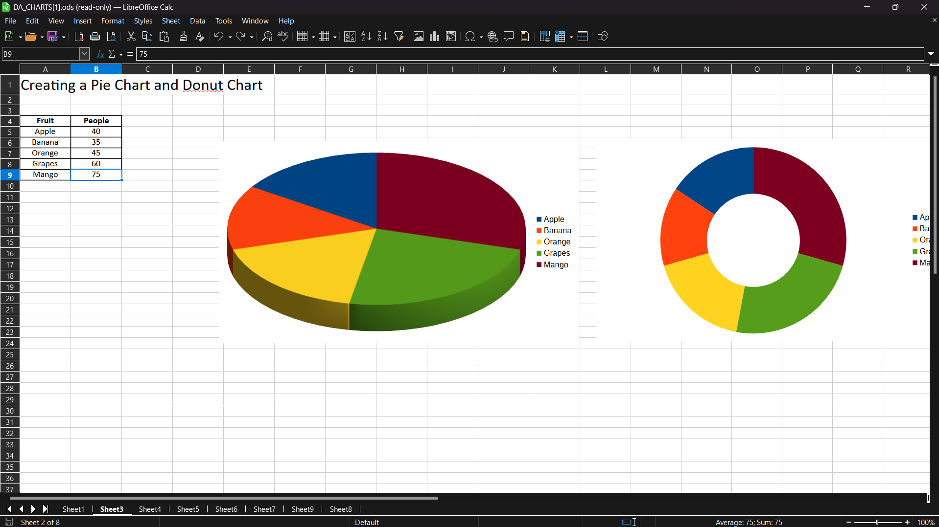
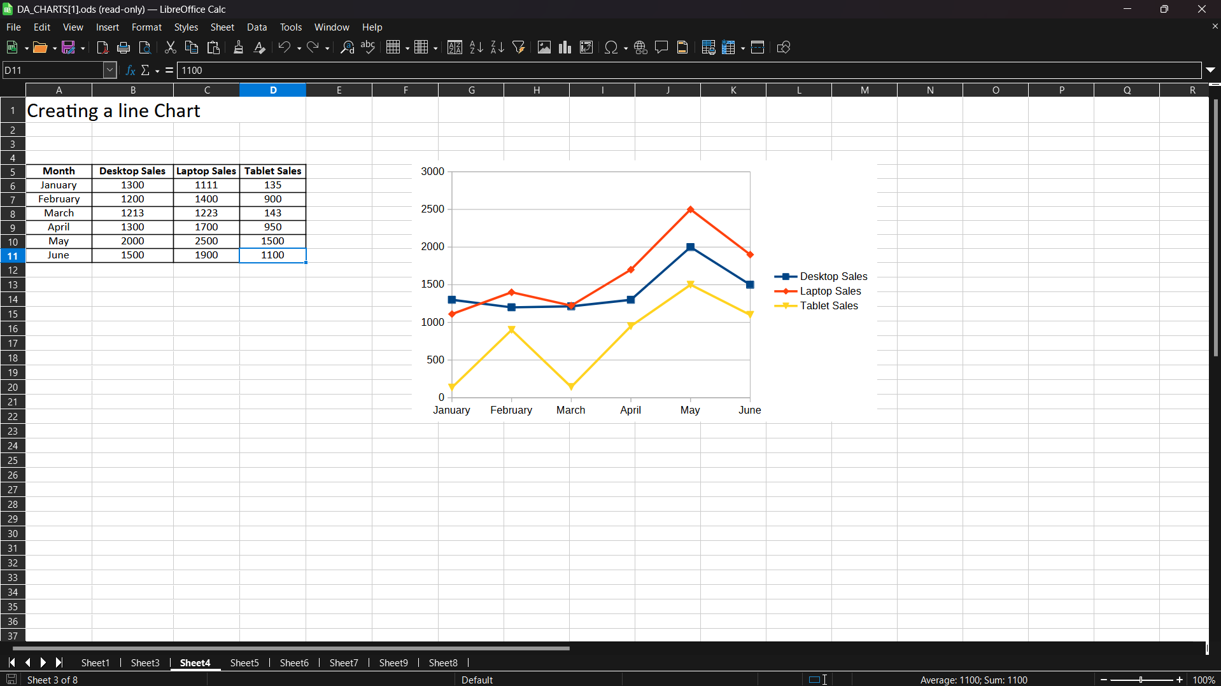
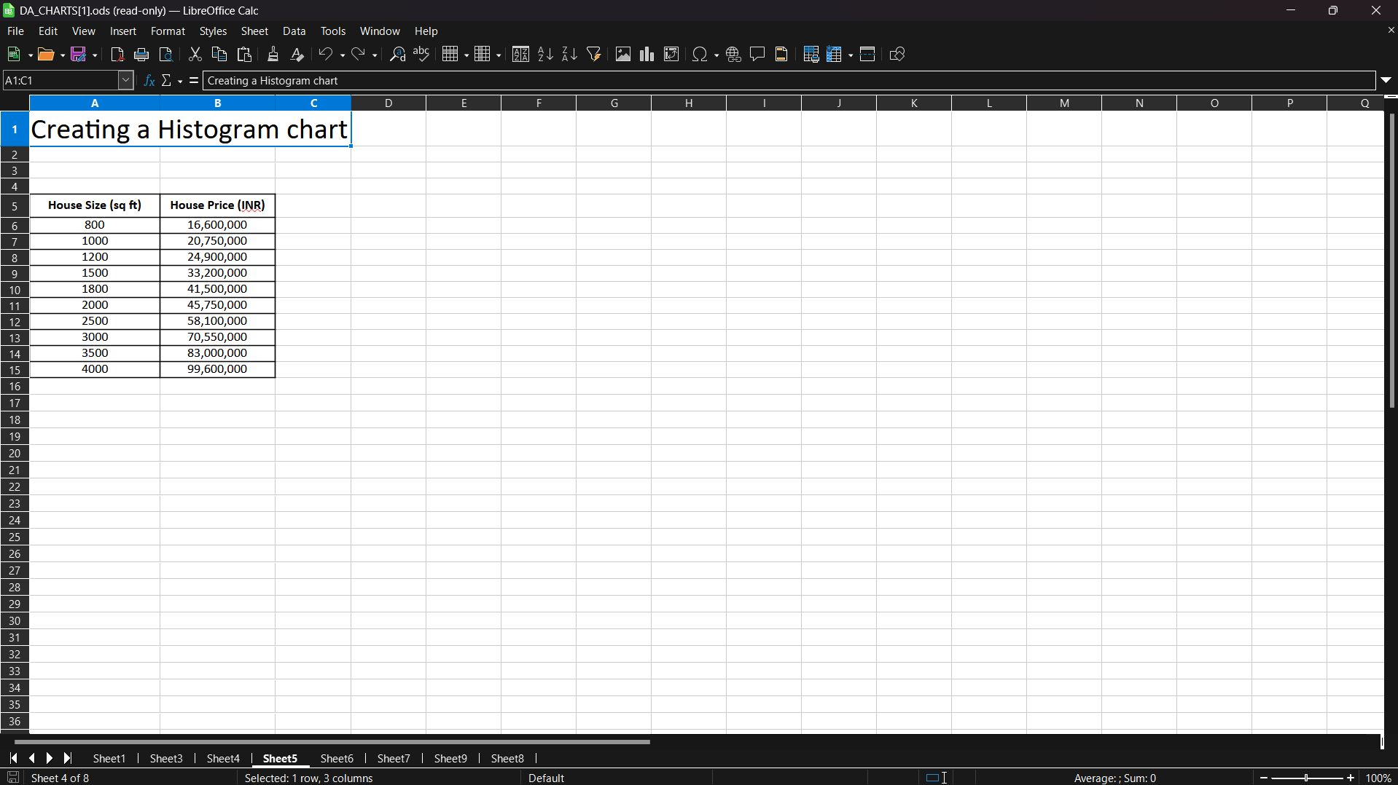
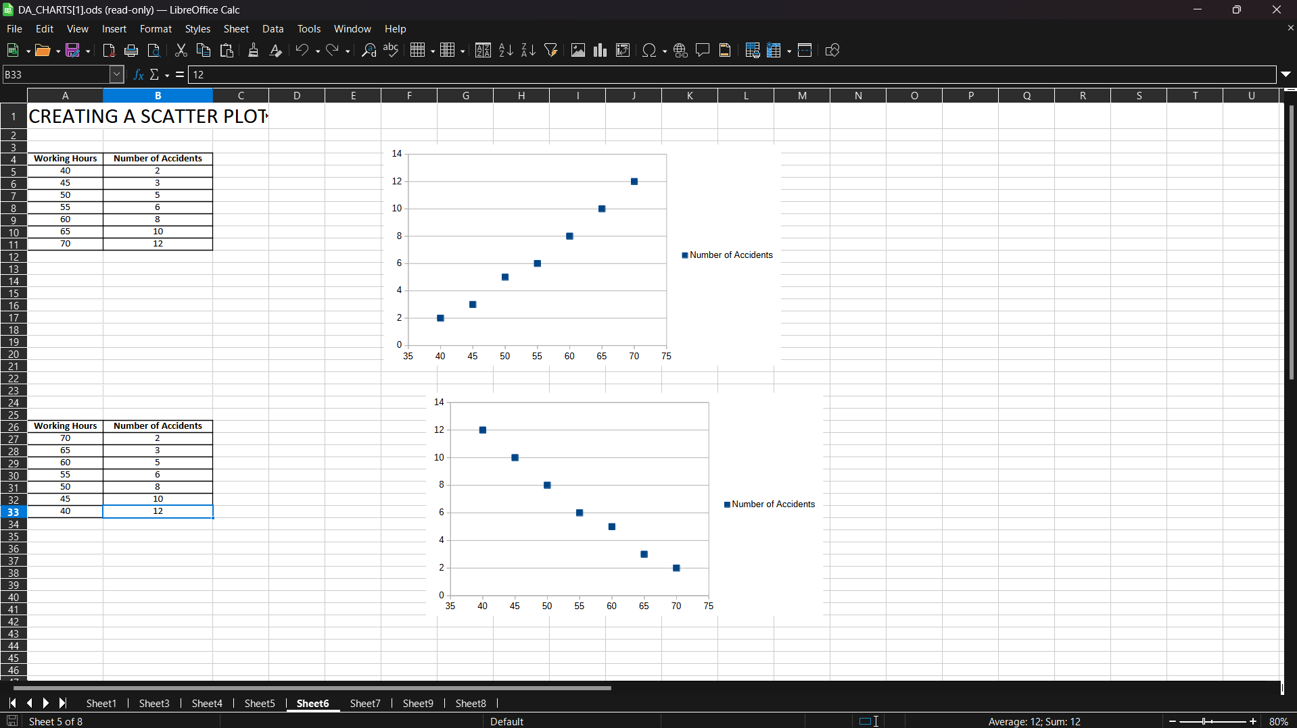
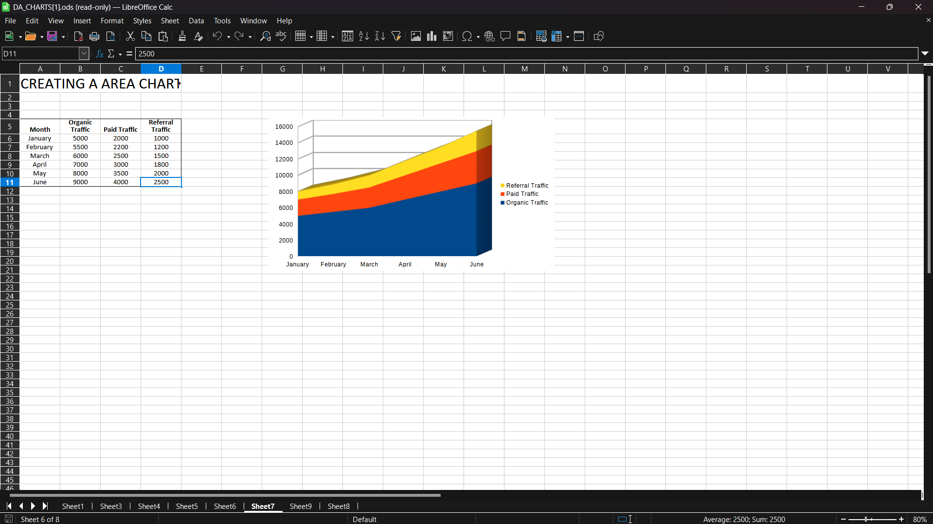
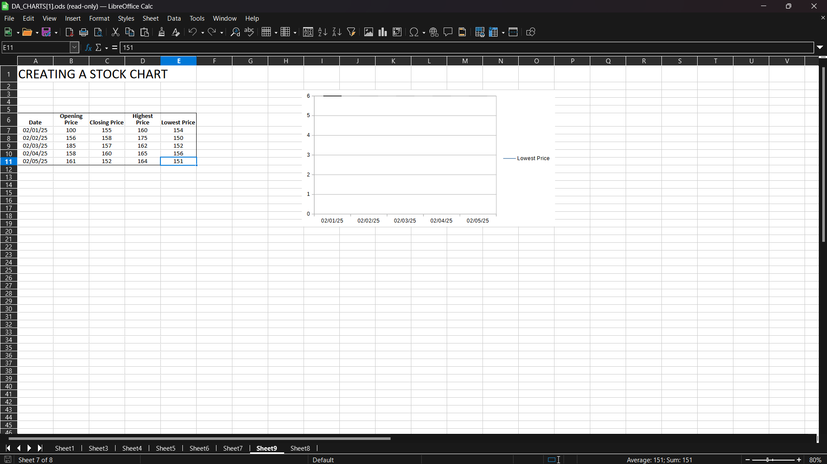
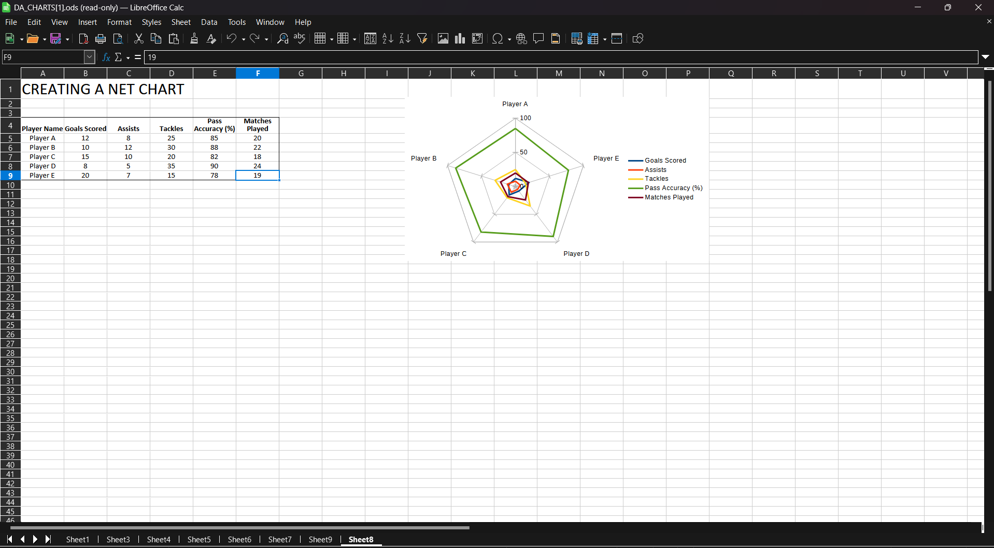

Conclusion

Short comings/ Limitations and Advantages of the Project

Conclusion
In conclusion, both OpenOffice and Excel offer a wide range of functionalities for data analysis, each with its own strengths. OpenOffice is a free and open-source alternative to Excel, making it accessible to a broader audience. Excel, on the other hand, is widely used in professional settings due to its advanced features and integration with other Microsoft Office applications. Understanding the capabilities of both tools can help users choose the right one for their specific data analysis needs.
Shortcomings/Limitations
One of the main limitations of OpenOffice is its lack of advanced features compared to Excel. While OpenOffice provides essential data analysis tools, it may not be suitable for users who require more sophisticated functionalities. Additionally, OpenOffice's user interface can be less intuitive for those accustomed to Excel, leading to a steeper learning curve. On the other hand, Excel's primary limitation is its cost, as it requires a subscription to Microsoft Office, which may not be affordable for all users.
Advantages
The advantages of using OpenOffice include its cost-effectiveness, as it is free and open-source, making it accessible to a wider audience. It also supports a variety of data analysis techniques, making it a versatile tool for both academic and professional use. Excel's advantages lie in its advanced features, user-friendly interface, and seamless integration with other Microsoft Office applications. These features make Excel a powerful tool for data analysis, particularly in professional settings where advanced functionalities are required.

Future Scope
Possible Modifications which are not made yet.
The future scope of data analysis techniques in OpenOffice and Excel is promising, with several advancements and trends expected to shape the landscape of data analysis. As the demand for data-driven decision-making continues to grow, both OpenOffice and Excel are likely to evolve to meet the needs of users across various industries.
One significant area of development is the integration of artificial intelligence (AI) and machine learning (ML) capabilities into these tools. AI and ML can enhance data analysis by automating complex tasks, providing predictive analytics, and offering insights that were previously difficult to obtain. For instance, future versions of OpenOffice and Excel may include advanced AI-driven features for anomaly detection, trend analysis, and automated data cleaning, making data analysis more efficient and accurate.
Another area of growth is the improvement of data visualization capabilities. As data becomes more complex, the need for sophisticated and interactive visualizations increases. Future updates to OpenOffice and Excel are expected to include more advanced chart types, customizable dashboards, and real-time data visualization options. These enhancements will enable users to better understand and communicate their data insights, facilitating more informed decision-making.
Collaboration and cloud integration are also expected to play a crucial role in the future of data analysis tools. With the rise of remote work and global teams, the ability to collaborate on data analysis projects in real-time is becoming increasingly important. Both OpenOffice and Excel are likely to enhance their cloud-based features, allowing users to access, share, and collaborate on data from anywhere in the world. This will streamline workflows and improve productivity, making it easier for teams to work together on data analysis tasks.
Furthermore, the future of data analysis in OpenOffice and Excel will likely see greater emphasis on data security and privacy. As data breaches and privacy concerns continue to make headlines, ensuring the security of sensitive information is paramount. Future versions of these tools are expected to incorporate advanced encryption, secure sharing options, and compliance with data protection regulations, providing users with peace of mind when handling confidential data.
Lastly, the integration of external data sources and APIs will become more seamless, allowing users to pull in data from various platforms and systems effortlessly. This will enable more comprehensive and holistic data analysis, as users can combine data from multiple sources to gain deeper insights and make more informed decisions.
In conclusion, the future of data analysis techniques in OpenOffice and Excel is bright, with advancements in AI and ML, data visualization, collaboration, security, and integration set to transform the way users analyze and interpret data. These developments will empower users to harness the full potential of their data, driving innovation and success in their respective fields.

References

- OpenOffice Documentation: OpenOffice.org Documentation
- Microsoft Excel Documentation: Microsoft Support - Excel
- Kaggle Datasets:
  - [Adult Income Dataset]
  - (https://www.kaggle.com/code/aditimulye/adult-income-dataset-from-scratch/output)
  - [Student Marks Dataset]
  - (https://www.kaggle.com/datasets/yasserh/student-marks-dataset/data)

